 | Dalhousie University  Faculty of Computer Science | 

CSCI 2141 Intro to Database Systems Fall-2016

Assignment 2 [50 marks]
Submission Deadline: TUESDAY, 11th OCTOBER at 12:00 noon

PROBLEM STATEMENT:
Carefully study the Data Model given below. You are required to implement this database using MySQL, populate the tables with the data provided, and use that database to answer the Assignment Tasks that follow.

DVDVidRental Database:
DVDVidRental is a new company that provides DVD Video Rentals. DVDVidRental can own several copies (VIDEO) of each movie (MOVIE). For example, the store may have 10 copies of the movie “The Shawshank Redemption”. “The Shawshank Redemption” would be one MOVIE and each copy would be a VIDEO. A rental transaction (RENTAL) involves one or more videos being rented to a member (MEMBERSHIP). A video can be rented many times over its lifetime, therefore, there is a M:N relationship between RENTAL and VIDEO. DETAILRENTAL is the bridge table to resolve this relationship. The complete ERD is provided in Figure below:

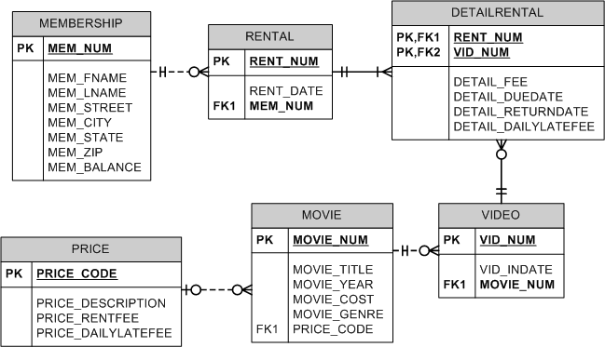

SUBMISSION INSTRUCTIONS:
- Use this document as an answer template.
- Complete and submit this document with your answers filled in (scripts and screenshots of the results of each task) through Brightspace, before the submission deadline.
- Remember to rename the document with your ID (e.g. B00123456.doc or docx)
- Doing with this assignment on your own will immensely improve your knowledge of SQL (The more you struggle with it, the more you learn. Do ask for help if you get “really” stuck)
ASSIGNMENT TASKS:
Part 1: CREATING THE TABLES [10 marks]
- Write the SQL script to create the table structures for the entities shown in the above Figure. The structures should contain the attributes specified in the ERD. Use data types that would be appropriate for the data that will need to be stored in each attribute. Enforce primary key and foreign key constraints as indicated by the ERD. Use this script to create this database in MySQL.
(Hint: You may need to consider the sequence in which to create the tables)
[Paste your script here]

- Generate the schema diagram for this database in MySQL and paste it in your assignment solution.
[Paste your MySQL schema diagram here]

Part 2: POPULATING THE DATABASE TABLES [10 marks]
See the attached file “DVDVidRental_Data.xls” that provides a sample of the data that will be kept in the database. This data needs to be inserted into the database for testing purposes. Write the INSERT commands necessary to place the data provided in the text file (DVDVidRental_Data.txt) in the tables that were created in Task 1. Use these commands to insert this data into the MySQL database that you created in Task 1. Remember to save your newly inserted data into the database using COMMIT;
Note: Carefully enter the data in the database, as incorrectly entered data may result in incorrect answers to the tasks given below in Section 3.
(Hint: You may need to consider the sequence in which to insert data into the tables.)

Part 3: [30 marks]
Write the SQL commands for accomplishing the following tasks. For each task, ensure that your command is correct by executing it in your MySQL database.
For each task, paste a screenshot of your results with your answers.: (See the example shown below for task ‘0’)

Example Task 0: Write a query to display the movie title, movie year, and movie genre for all movies.
Answer) SELECT MOVIE_TITLE, MOVIE_YEAR, MOVIE_GENRE
FROM MOVIE;

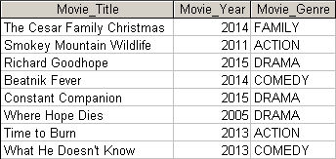

Tasks:
- Write the SQL command to change the movie year for movie number 1245 to 2015.
[Paste your SQL command here]
[Paste the screenshot of your result here]
– Repeat this for each of the tasks below

- Write the SQL command to change the price code for all Action movies to price code 3.

- Write a single SQL command to increase all price rental fee values in the PRICE table by $1.00

- Write a query to display the movie title, movie year, and movie genre for all movies sorted by movie genre in ascending order, then sorted by movie year in descending order within genre.

- Write a query to display the movie number, movie title, and price code for all movies with a title that starts with the letter “R”.

- Write a query to display the movie title, movie year, and movie cost for all movies that contain the word “hope” anywhere in the title. Sort the results in descending order by title.

- Write a query to display the movie number, movie title, movie cost, and movie genre for all movies that are either action or comedy movies and that have a cost that is less than $50. Sort the results in ascending order by genre.

- Write a query to display the membership number, name, street, state, and balance for all members in Tennessee (TN), with a balance less than $5, and whose street name ends in “Avenue.”

- Write a query to display the movie genre, the number of movies in each genre and the average cost of movies in each genre.

- Write a query to display the movie title, movie genre, price description, and price rental fee for all movies with a price code.

- Write a query to display the movie title and the movie cost divided by the price rental fee for each movie that has a price to determine the number of rentals it will take to break even on the purchase of the movie.

- Write a query to display the movie title, price description, and price rental fee for all movies that are in the genres Family, Comedy, or Drama.

- Write a query to display the minimum balance, maximum balance, and average balance for memberships that have a rental.

- Write a query to display the rental number, rental date, video number, movie title, due date, and return date for all videos that were returned after the due date. Sort the results by rental number and movie title.

- Write a query to display the movie number, movie genre, average movie cost of movies in that genre, movie cost of that individual movie, and the percentage difference between the average movie cost and the individual movie cost.
Note: the percentage difference is calculated as the cost of the individual movie minus the average cost of movies in that genre, divided by the average cost of movies in that genre multiplied by 100. For example, if the average cost of movies in the “Family” genre is $25, if a given Family movie cost $26, then the calculation would be ((26 – 25) / 25 * 100), which would work out to be 4.00%. This indicates that this movie costs 4% more than the average Family movie.

